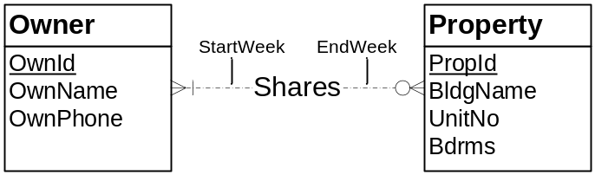
Figure 3: ERD for Conversion Problem 6
- Owner( PRIMARY KEY (OwnID), OwnName, OwnPhone)
- Property( PRIMARY KEY (PropID), BldgName, UnitNo, Bdrms)
- Shares( PRIMARY KEY (OwnID,PropID), StartWeek, EndWeek)
FOREIGN KEY (OwnID) REFERENCES Owner
FOREIGN KEY (PropID) REFERENCES Property

Conversion Rule:
- Use Entity type rule to convert each entity.
- Use M-N rule to convert the Shares relationship.

